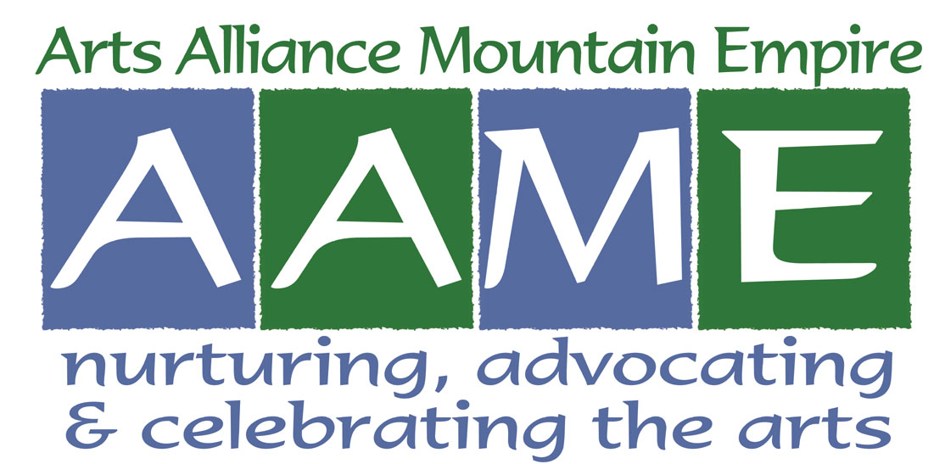
Arts Alliance Mountain Empire
P. O. Box 94, Bristol, TN 37621
Publisher of A! Magazine for the Arts
www.artsmagazine.info

A! Magazine for the Arts 2018 Advertising Rates and Dimensions

Why advertise in A! Magazine for the Arts?
Your ad reaches readers who love the arts. Advertisers are partners in support of the arts.
Advertising provides the largest source of revenue for the production of A! Magazine for the Arts.

Black-White Ads (cost per ad) Four-Color Ads (cost per ad)
Size | 1 ad | 6 ads in 1 year | 12 ads in 1 year |  | 1 ad | 6 ads in 1 year | 12 ads in 1 year
1/8 page | $ 95 | $ 85 | $ 75 |  | $ 150 | $ 125 | $ 110
¼ page | $ 180 | $ 165 | $ 150 |  | $ 285 | $ 240 | $ 205
½ page | $ 340 | $ 310 | $ 280 |  | $ 515 | $ 460 | $ 375
Full page | $ 655 | $ 595 | $ 545 |  | $ 895 | $ 830 | $ 720

Ad Dimensions
Size of ad | Vertical | Horizontal | Square
1/8 page | 2.25” x 4.625” | 4.625” x 2.25” | n/a
¼ page | 2.25” x 9.5” | 9.5” x 2.25” | 4.625” x 4.625”
½ page | 9.5” x 4.625” | 9.5” x 4.625” | n/a
Full page | 9.5” x 9.5” | n/a | n/a

Discounts are available
Advertisers who contract 6 or 12 ads per year pay lower costs per ad compared with single ads.
Donors to Arts Alliance Mountain Empire, a 501(c)3 organization and publisher of A! Magazine for the Arts,
receive a 10% discount on the cost of advertising.

For assistance and information
Advertising documents, including current rates, Advertising Agreement, and publication deadlines are available at www.artsmagazine.info. Select ADVERTISE from the drop-down menu bar.

To reserve advertising space, contact Ben Jennings, 276-628-5960, ben.h.jennings@gmail.com, or Ann Holler, 423-652-7462, aholler@btes.tv
Submit ad designs to Leslie Grace, 423-383-4495, artsmagazine@aamearts.org

Give additional support to AAME and A! Magazine for the Arts
Additional gifts are welcome, as advertising revenue provides only part of the funding needed for the continued publication of A! Magazine for the Arts. Gifts made annually to Arts Alliance Mountain Empire in the following amounts will qualify for the 10% discount on the cost of advertising:

Individual $25
Volunteer-Operated Non-Profit $50
Professional-Staffed Non-Profit, School, College, University, or Library $75
For-Profit Business or Corporation $100

Gifts beyond these amounts are always gratefully received and serve to promote arts awareness in our region.
Please make checks to Arts Alliance Mountain Empire and mail to P. O. Box 94, Bristol, TN 37621.

A! Magazine for the Arts is sponsored by Bristol Herald Courier and supported in part by the Tennessee Arts Commission

