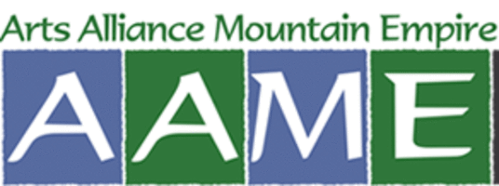

THE ARTS ALLIANCE GALA

Holiday Inn Bristol, Virginia

May 16, 2020

Tickets $100

WHAT WE DO:
- Finance, oversee, plan, produce and distribute A! Magazine for the Arts to 20,000 readers each month.

- Sponsor a Speaker Series that focuses on all of the arts with organizations such as The Birthplace of Country Music, Bristol Public Library and William King Museum of Art.

- Recognize at the Gala area contributors to the arts in these categories: artist, arts educator, arts administrator and arts advocate. Nominees are solicited from the community.

SPONSORSHIP:

- Sponsorship helps to cover the cost of the Gala, so proceeds from ticket sales and silent art auction (items donated by local artists) can fund A! Magazine for the Arts and speaker fees.

- For a $500 contribution, you receive recognition in the Gala program and in the July issue of A! Magazine.

- For a $750+ contribution, you receive the above recognition plus a 1/4 page black & white ad in A! Magazine.

- Arts Alliance is a tax-exempt non-profit under section 501(c)3 of the Internal Revenue Code. Our federal tax identification number is 68-0558941.

