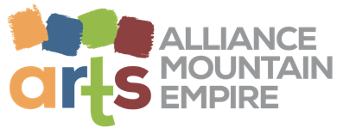 ARTS ALLIANCE GALA SPONSORSHIP
SPONSORSHIP DONATION FORM
YES! I want to nurture, advocate, and celebrate the arts by supporting the Arts Alliance’s fundraiser Gala on May 21, 2022
Your commitment ensures that our organization’s dedication to supporting the arts remains strong.
GOLD
$500
- Acknowledgement in a future issue of A! Magazine for the Arts
- Recognition in the Gala Program
PLATINUM
$750
- Acknowledgement in a future issue of A! Magazine for the Arts
- Recognition in the Gala Program
- A quarter page black & white ad in A! Magazine

Contact Name:_____________________________________________________
Company Name:____________________________________________________
Mailing Address:____________________________________________________
Phone:_____________________ Email Address:__________________________
Donated amount____________ Sponsor Signature________________________
Mail form and donation by 4/22/2022: To have your donation picked up:
AAME Please email Ostergf@gmail.com or
P.O. Box 94 call 423-646-3024
Bristol, TN 37621
Thank you for your support!

